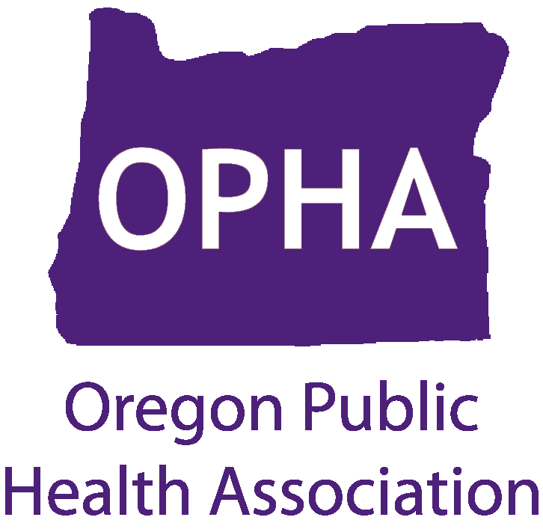

OPHA 2015 Legislative Session Debrief
Join the OPHA Policy Committee on Thursday, July 9th at 4 pm for a legislative debrief. An overview of the 2015 legislative session will be presented, along with a review of major public health legislation and next steps.
Presenters include: OPHA Board members Katy King, a government relations consultant, Rosa Kline, OHA interim Legislative Director and also Morgan Cowling, Executive Director of the Conference of Local Health Officials.

Date: Thursday, July 9, 2015
Time: 4-5pm
Location: Portland State Office Building - Room 368 (800 NE Oregon Street, Portland, OR 97232)

*Call-in option available: Dial 1-800-201-2375 and follow the prompts to enter pass code 116160#

For more information visit: http://www.oregonpublichealth.org/advocacy

